SIMATS ENGINEERING (SAVEETHA SCHOOL OF ENGINEERING)
Course Code & Title: | ECA5604 -5G/6G COMMUNICATION | Course Faculty: | Dr.K.Sathish
Student Name: | Velamuri Bhanodhay | Reg. No.: | 192412330
Dept / Batch: | BE.ECE / 2024 | Date: | 10/8/2026
Lab Observation

Experiment 9 : Massive MIMO Capacity vs SNR and Gain Using MATLAB

Objective 1: Analyze the channel capacity of a Massive MIMO system for different signal-to-noise ratio (SNR) values using MATLAB. Observe how channel capacity increases with improving signal quality
based on the Shannon capacity principle.

Matlab Code:

clc;
clear;
close all;
snr = 0:5:30;
snr_linear = 10.^(snr/10);
capacity = log2(1 + snr_linear);
figure;
plot(snr,capacity,'-o','LineWidth',2,'MarkerSize',6);
grid on;
xlabel('SNR (dB)');
ylabel('Channel Capacity (bps/Hz)');
title('Channel Capacity vs SNR');

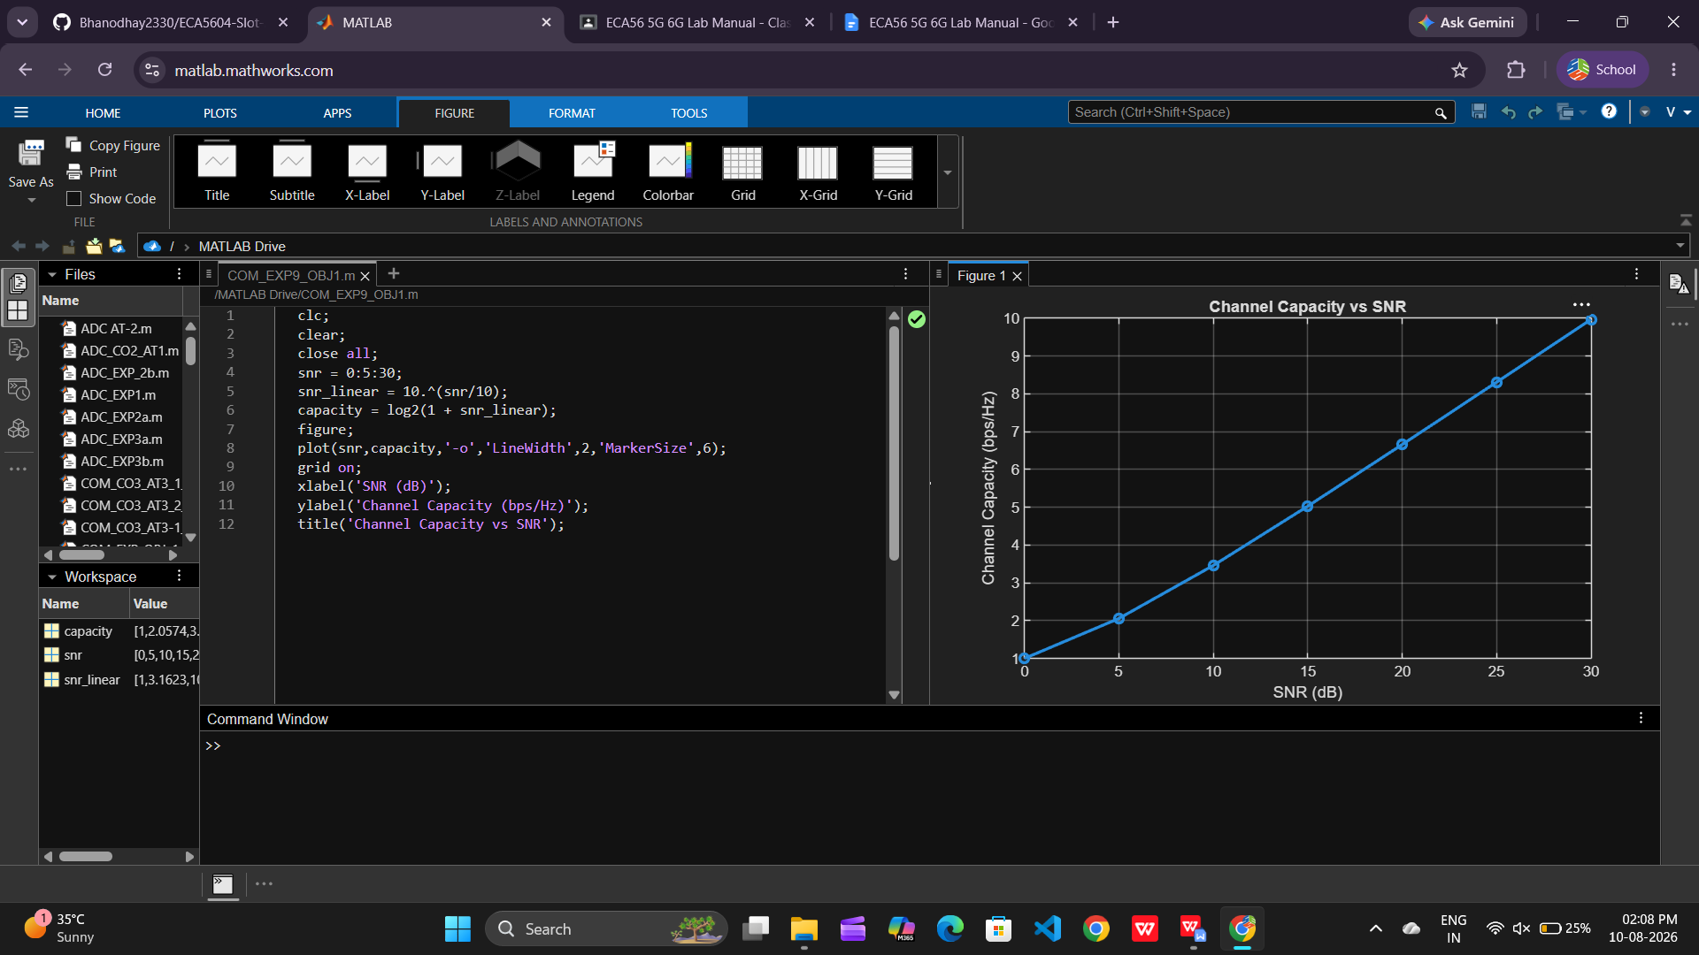

Objective 2: Compare the signal-to-noise ratio for different communication scenarios using MATLAB.
Analyze the effect of SNR on the quality and reliability of wireless communication in Massive
MIMO systems.

Matlab Code:

clc;
clear;
close all;
snr = 0:5:30;
snr_linear = 10.^(snr/10);
capacity = log2(1 + snr_linear);
figure;
plot(snr,capacity,'-o','LineWidth',2,'MarkerSize',6);
grid on;
xlabel('SNR (dB)');
ylabel('Channel Capacity (bps/Hz)');
title('Channel Capacity vs SNR');

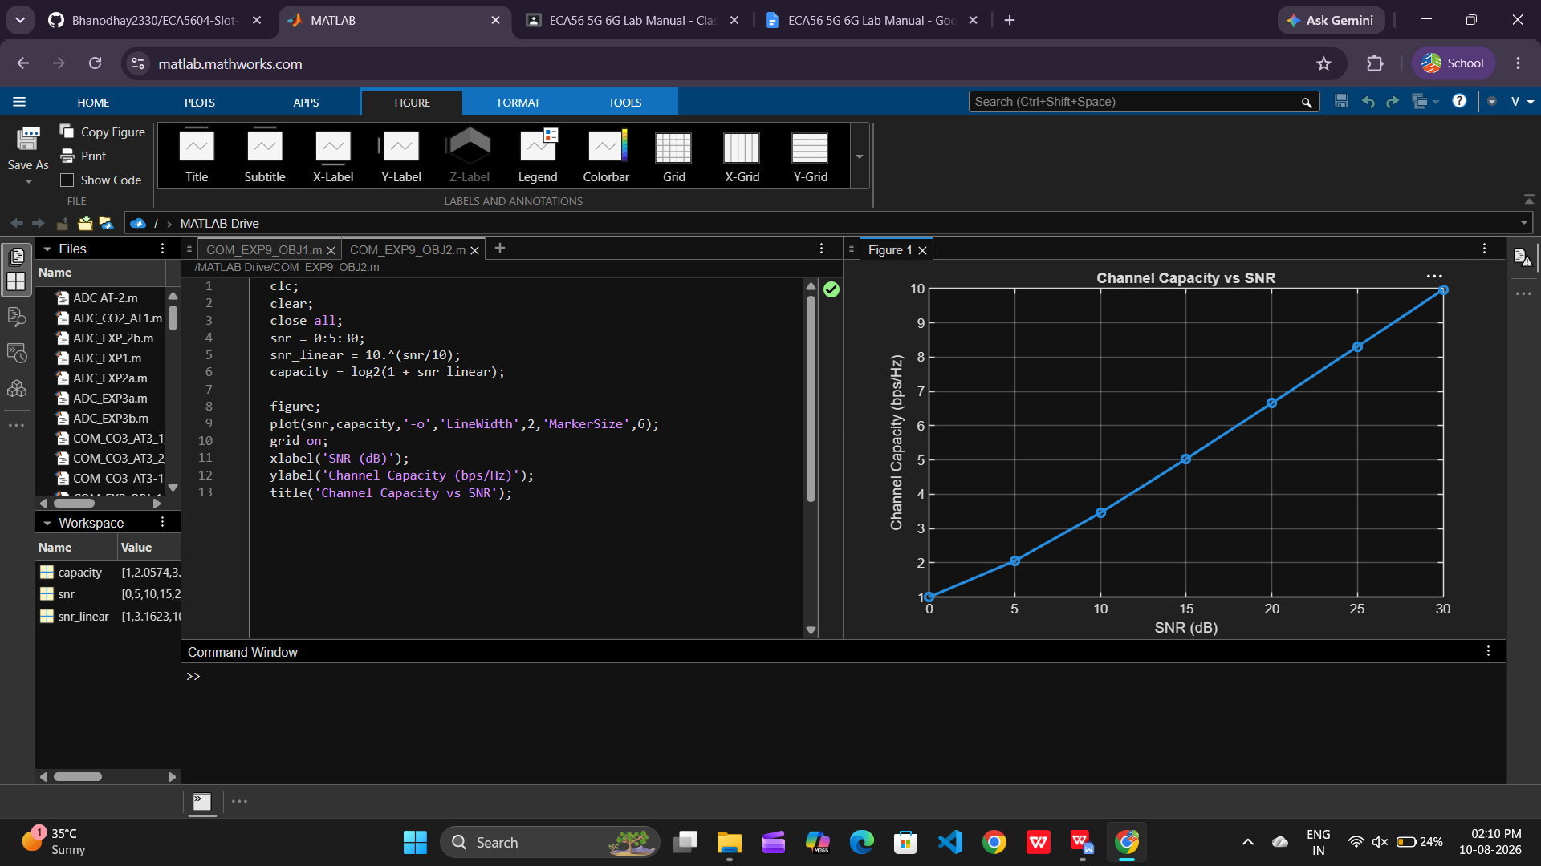

Objective 3: Analyze the antenna gain achieved by varying the number of antenna elements in a Massive
MIMO system using MATLAB. Observe how increasing the antenna array size improves
directional gain and enhances communication performance.

Matlab Code:

clc;
clear;
close all;
antennas = [4 8 16 32 64]; % Number of Antenna Elements
gain = 10*log10(antennas); % Antenna Gain (dB)
figure
bar(antennas, gain)
grid on
xlabel('Number of Antenna Elements')
ylabel('Antenna Gain (dB)')
title('Antenna Gain for Different Antenna Array Sizes')

